DATA ANALYTICS ASSIGNMENT 3

G.Naga Tejaswi

20NN1A05D6

IV B.TECH (CSE)

VIGNAN’S NIRULA INSTITUTE OF TECHNOLOGY AND SCIENCE FOR WOMEN (VNITSW)

DATASET : [Sample - Superstore.xls](https://docs.google.com/spreadsheets/d/1Vmsk3xJ_qp69U0AZzCpNybqX0AP4KSon/edit#gid%3D972120833)



* **Define at least two sets based on specific criteria from your dataset (e.g., high-value customers, top-performing products).**
* **Experiment with combining sets using UNION, INTERSECT, and MINUS operations.**
* **Create 2 Calculation field using any aggregate function**
* **Create any 3 visualization using quick Table Calculations**

HIGH-VALUE CUSTOMERS BY SALES

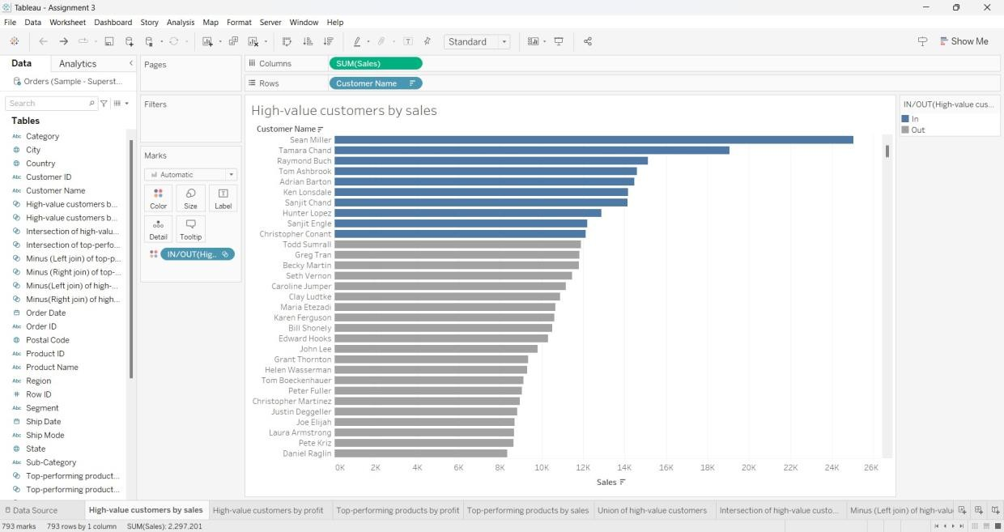

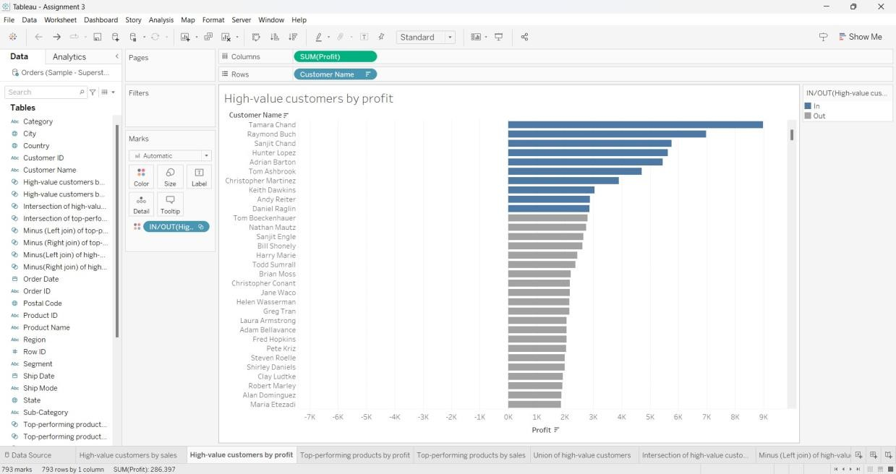

UNION OF HIGH-VALUE CUSTOMERS

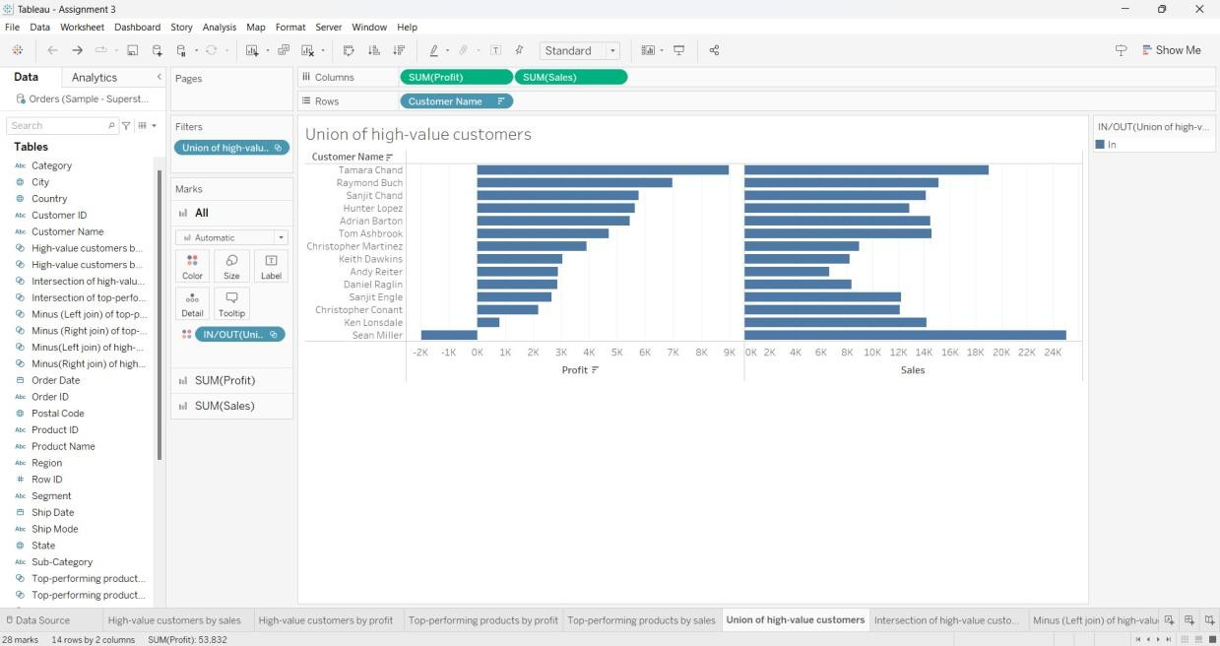

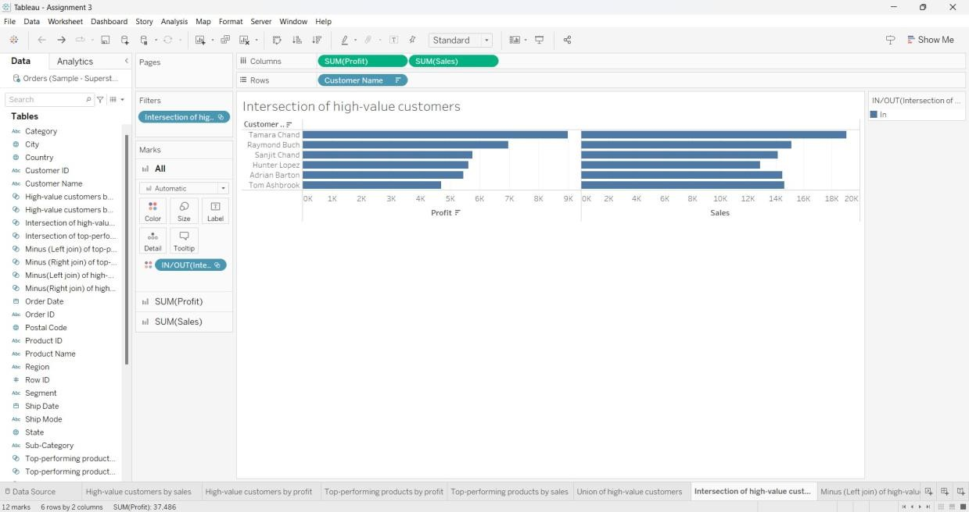

MINUS (LEFT JOIN) OF HIGH-VALUE CUSTOMERS

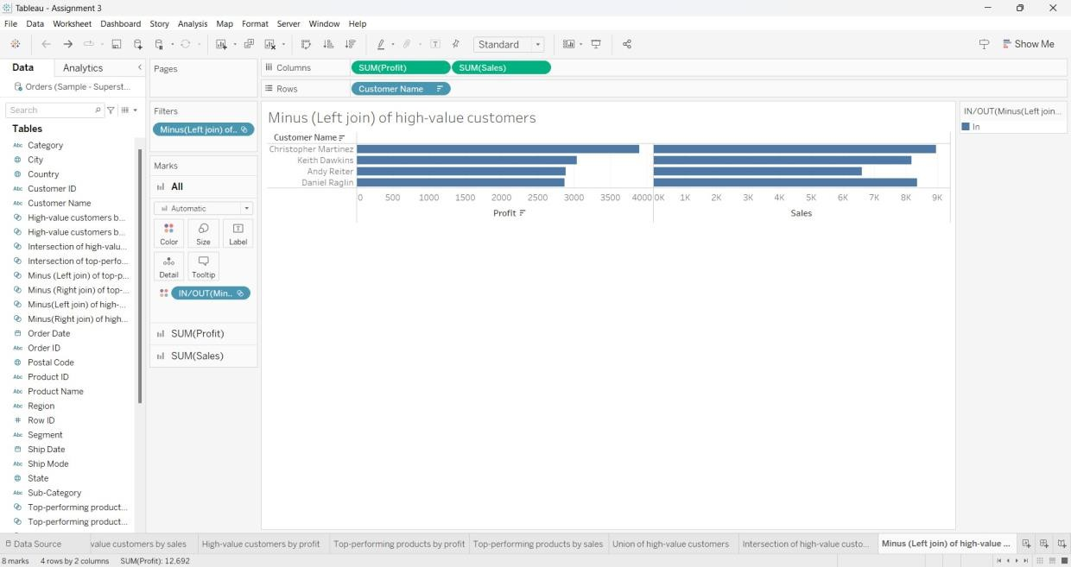

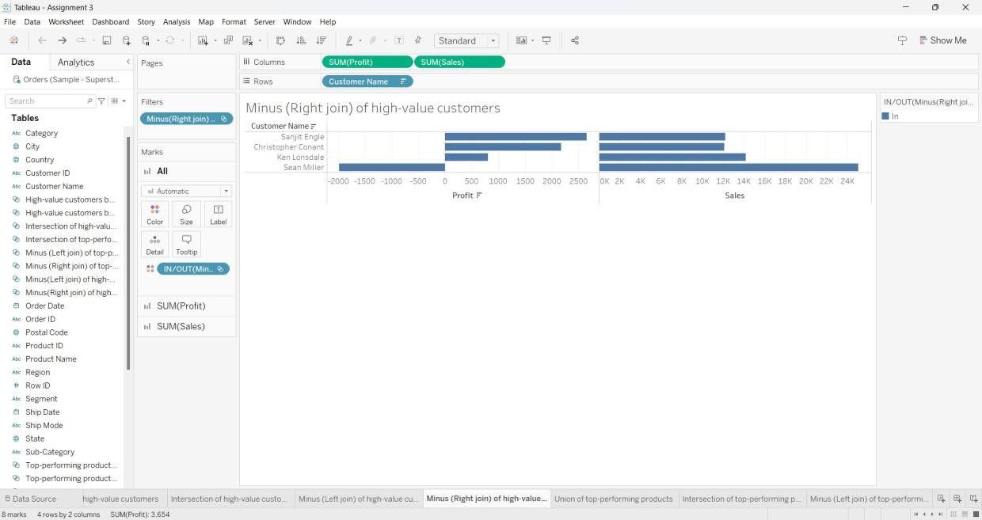

TOP-PERFORMING PRODUCTS BY PROFIT

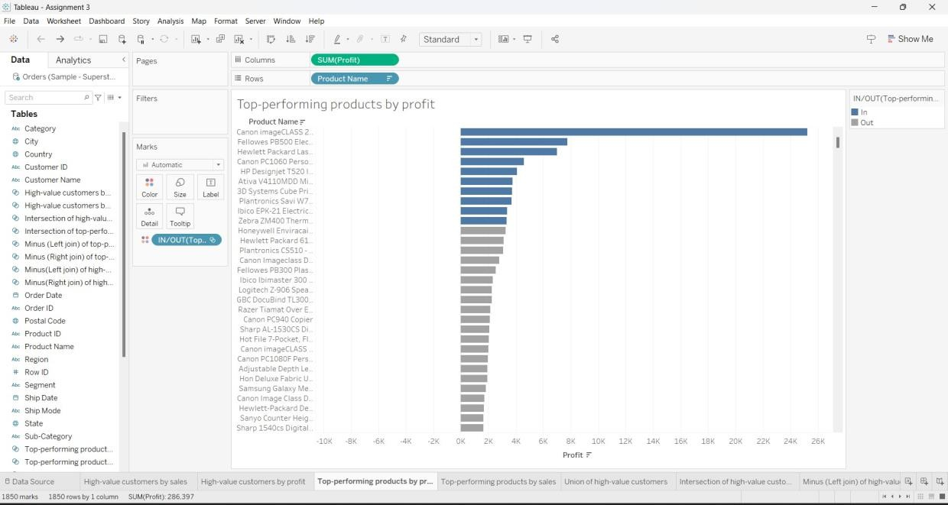

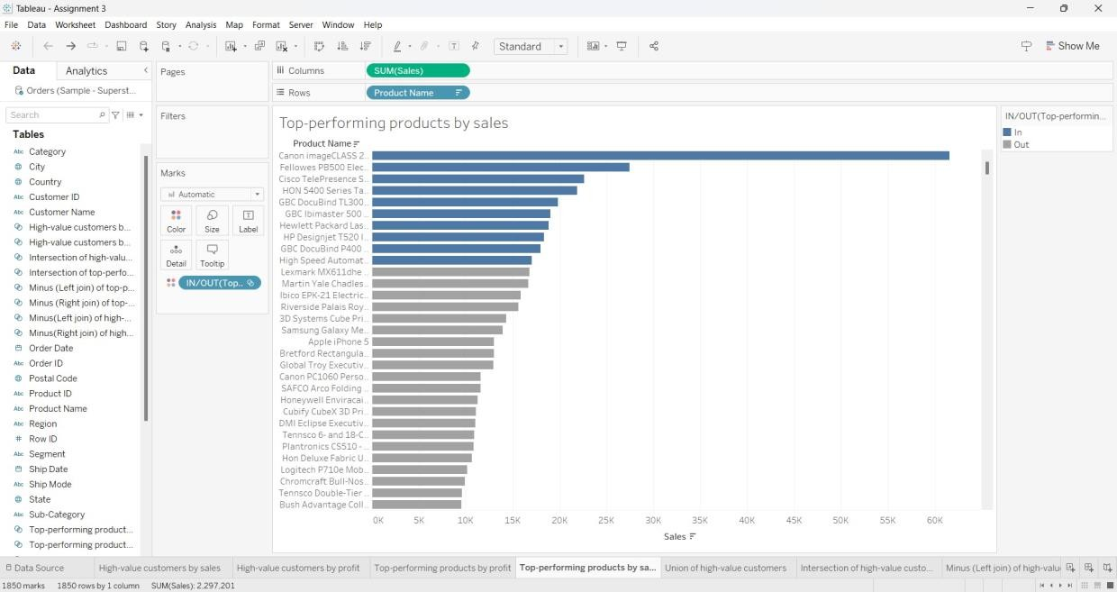

UNION OF TOP-PERFORMING PRODUCTS

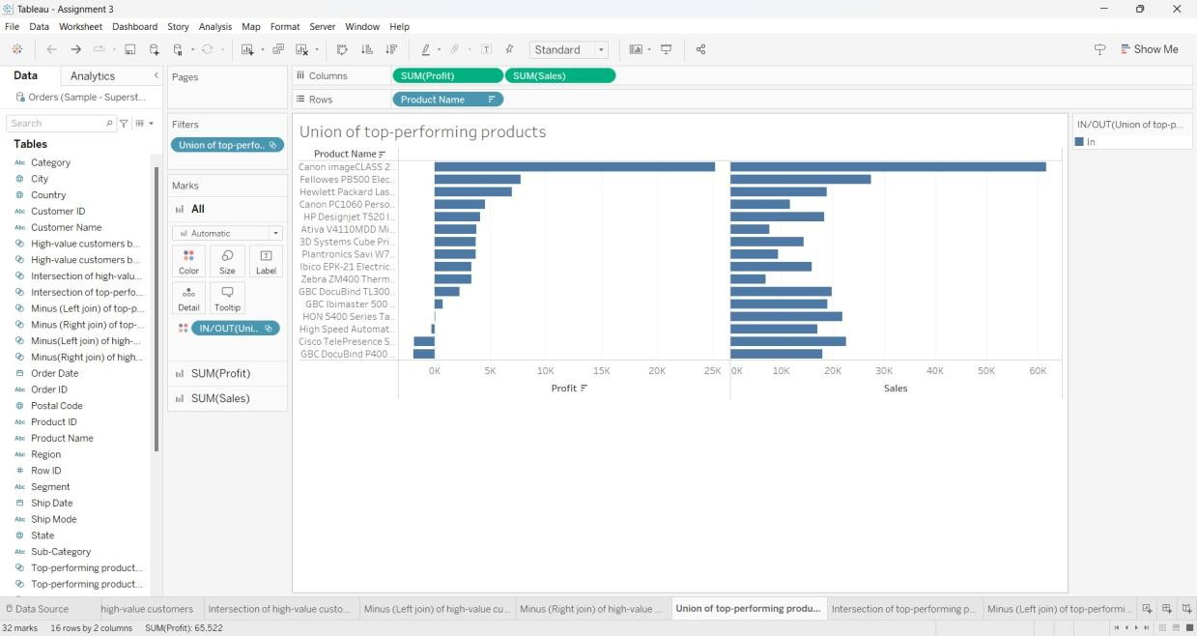

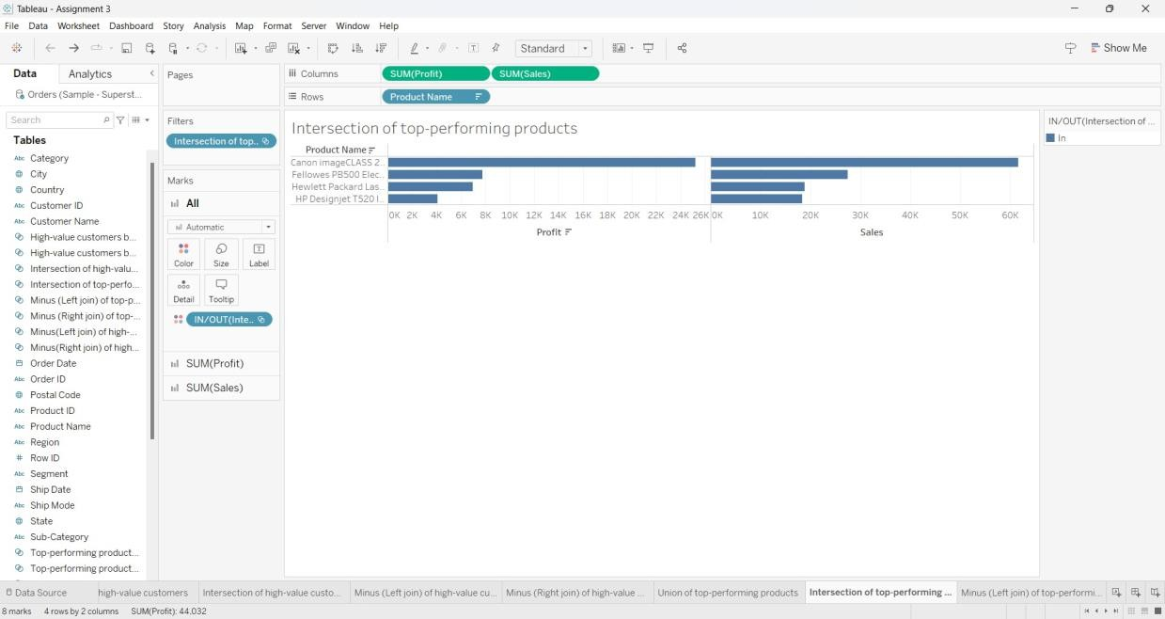

MINUS (LEFT JOIN) OF TOP-PERFORMING PRODUCTS

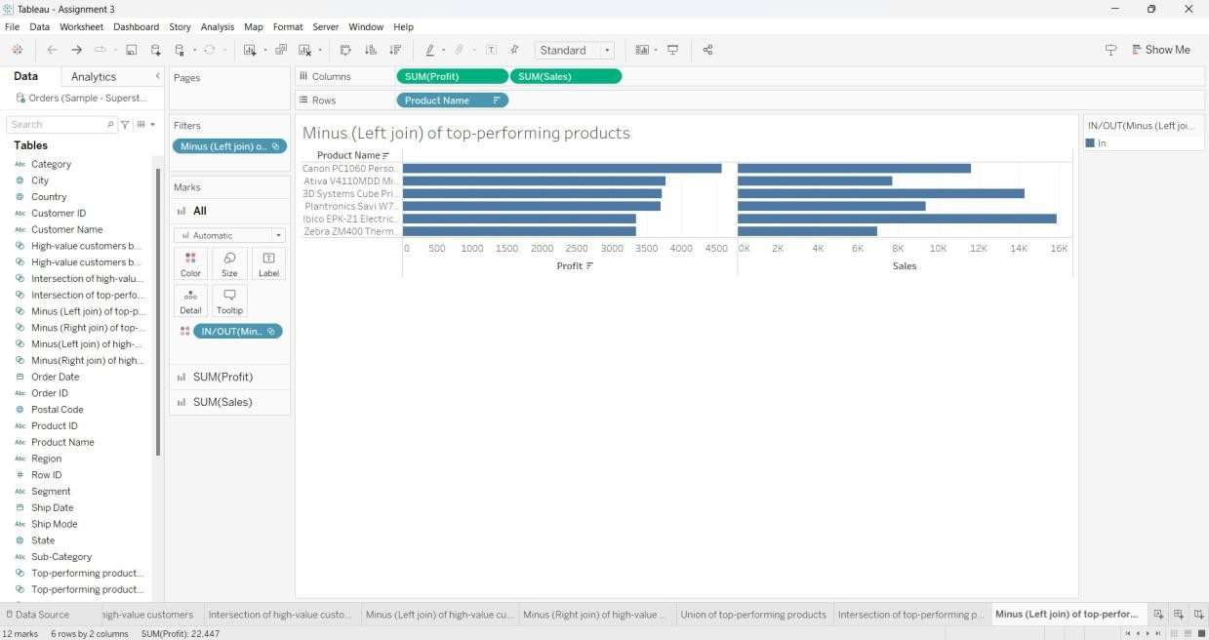

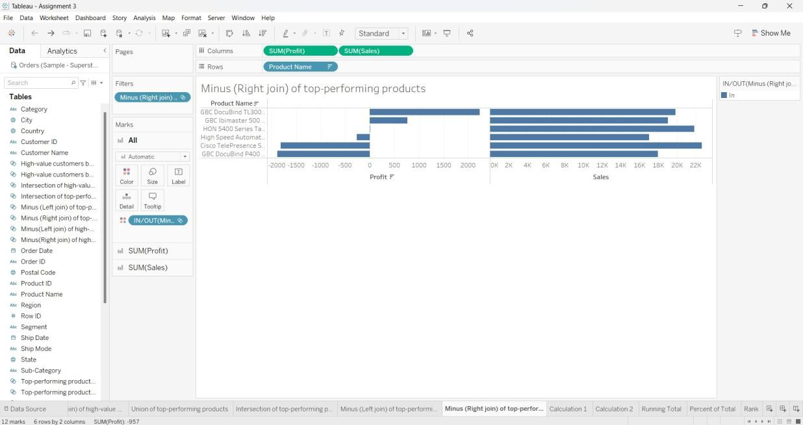

CALCULATED FIELD - 1

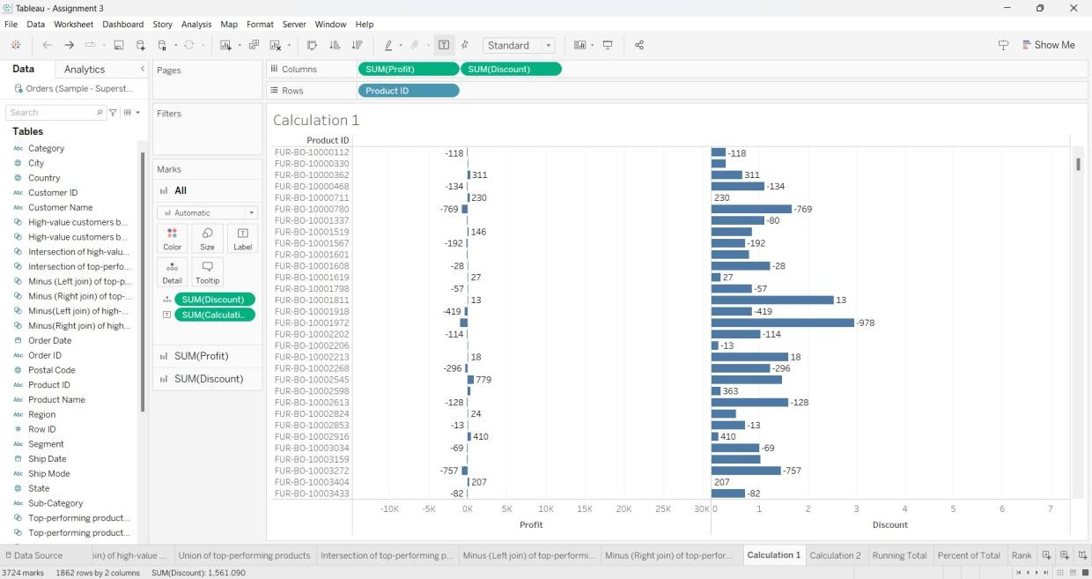

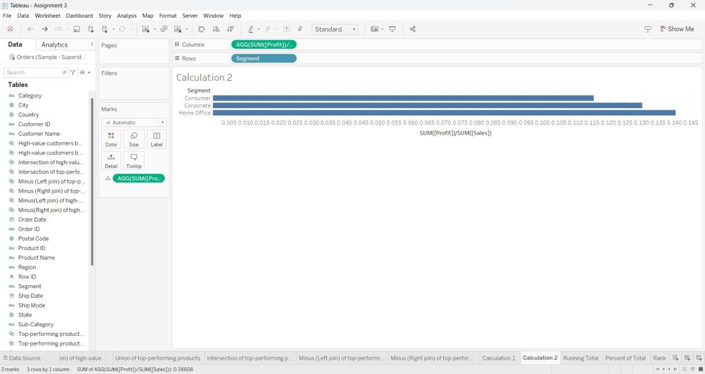

QUICK TABLE CALCULATIONS: RUNNING TOTAL

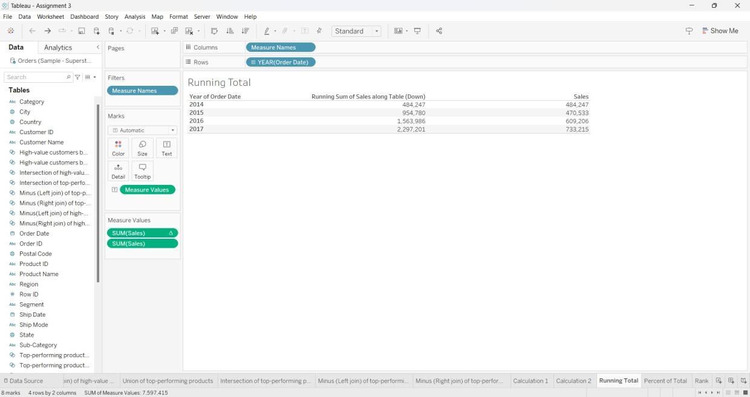

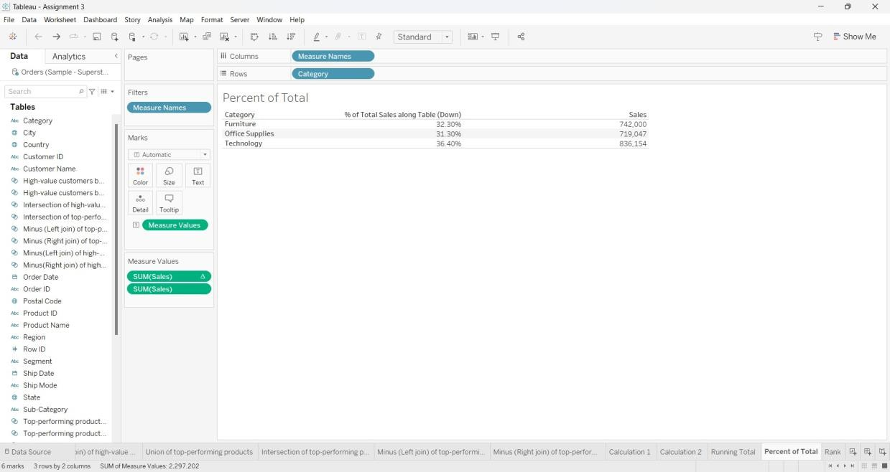

RANK

